**ABSTRACT**

This paper presents the design of a vibratory MEMS Gyroscope based on minimum output current and bandwidth which are 0.1 nA/degree/sec and 50 Hz respectively. The Quality factor Q=100 has been achieved. The drive frequency and sense frequency are considered the same and equal to 10 kHz [1]. Drive voltage is 30 V. We exploited the fact that parallel plate capacitors give large changes in current for a small change in the gap to make the gyroscope more sensitive. On the drive side, comb-drive has been used. For the fabrication, we have discussed the SiOG (Silicon on glass) process for the reasons explained [2].

**INTRODUCTION**

The vibratory gyroscope design presented works on the principle of Coriolis force. It has two modes, drive mode and sense mode. The structure as shown in the fig. 1 consists of a drive mass and as sense mass, the drive mass is electrostatically actuated by a comb drive at a sinusoidal frequency equal to the resonant frequency. It is connected to the substrate through the clamped guided spring structure, similarly, the sense mass is connected to the drive mass through the spring. The structure is designed to rotate about the z-axis with reference to the coordinate system as established in the figure. When a sinusoidal voltage is applied to the comb drive, the drive mass oscillates in x-direction. When there is no rotation about the z-axis, the drive mass and in turn the sense mass keep oscillating in the x-direction. When the device starts rotating at a constant angular speed, the sense mass experiences a Coriolis force with magnitude and direction determined by the angular rotation rate and the sense mass itself. The displacement of the sense mass is related to the angular speed by the equation. This change in displacement changes the capacitance of parallel plate capacitors which are formed by the sense mass and the stator plates fixed to the substrate. A bias voltage across the capacitor then makes current flow through the circuit which is the measure of the angular speed. For our design, the minimum current for an angular rate of one degree/sec is 0.1 nA. The maximum rotation rate is limited by the pull-in phenomenon in the parallel plate capacitor which limits the maximum displacement to ⅓g, where g is in the gap between the plates.

**II. DEVICE DESIGN**

The gyroscope design is as shown in the fig.1 and fig 2:

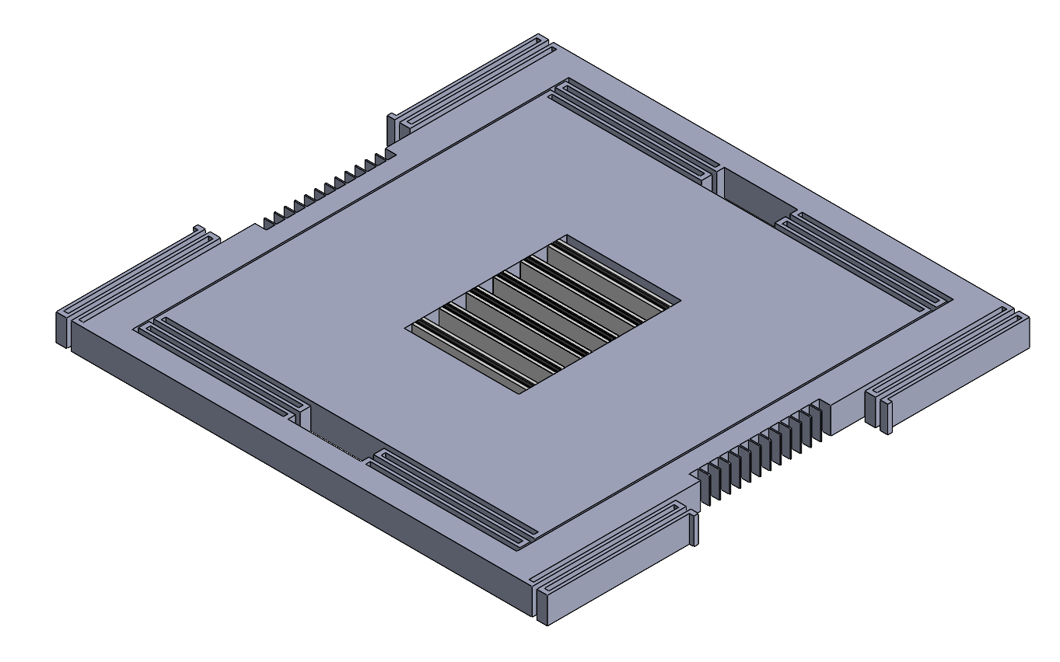



Shown below is the top view of the gyroscope structure:

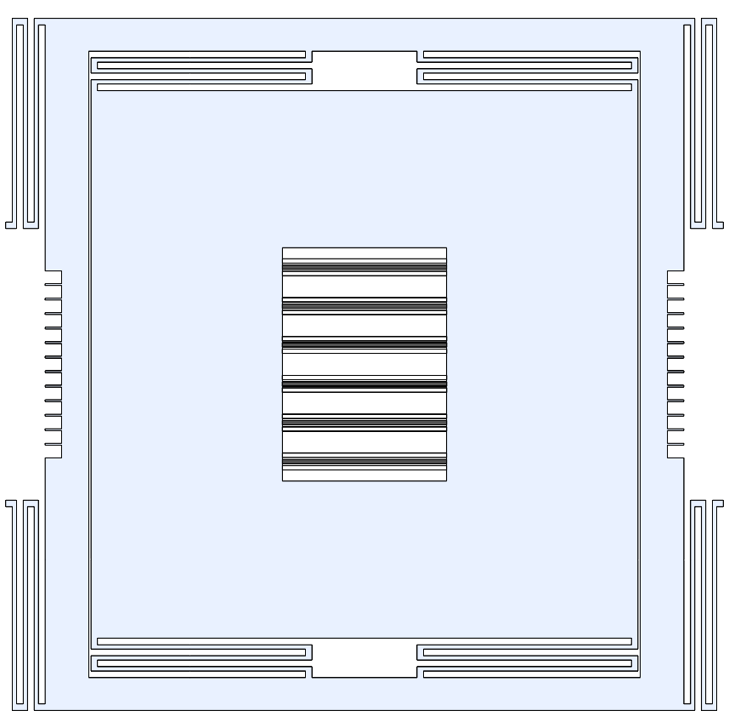

**III. MODELING RESULTS OR CALCULATIONS**

The design process is as follows:

The governing equation for sense side of the gyroscope is:

Sense side:

[](https://www.codecogs.com/eqnedit.php?latex=m%5Cddot%7By%7D%20%2B%20c%5Cdot%7By%7D%20%2B%20ky%20%3D%20F_%7B%5Ctext%7BCoriolis%7D%7D#0)

Sensed displacement:

[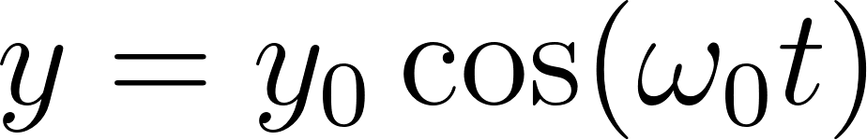](https://www.codecogs.com/eqnedit.php?latex=y%20%3D%20y_0%20%5Ccos(%5Comega_0%20t)#0)

Sense current is given by:

[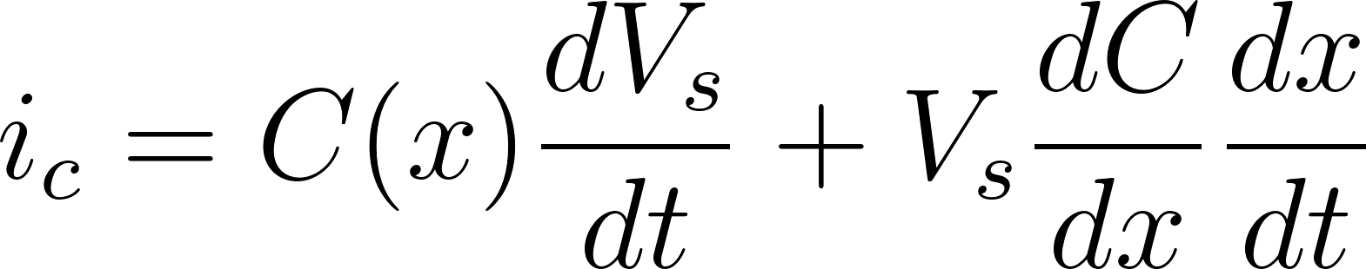](https://www.codecogs.com/eqnedit.php?latex=i_c%20%3D%20C(x)%20%5Cfrac%7BdV_s%7D%7Bdt%7D%20%2B%20V_s%20%5Cfrac%7BdC%7D%7Bdx%7D%20%5Cfrac%7Bdx%7D%7Bdt%7D#0)

As the bias voltage on the sense side is constant:

[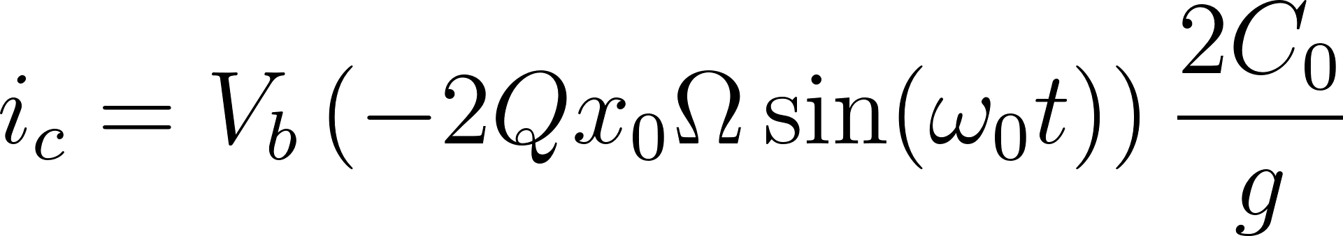](https://www.codecogs.com/eqnedit.php?latex=i_c%20%3D%20V_b%20%5Cleft(-2%20Q%20x_0%20%5COmega%20%5Csin(%5Comega_0%20t)%5Cright)%20%5Cfrac%7B2%20C_0%7D%7Bg%7D#0)

Current per unit angular rotation rate:

[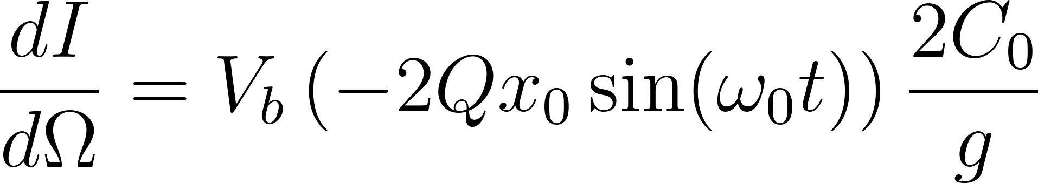](https://www.codecogs.com/eqnedit.php?latex=%5Cfrac%7BdI%7D%7Bd%5COmega%7D%20%3D%20V_b%20%5Cleft(-2%20Q%20x_0%20%5Csin(%5Comega_0%20t)%5Cright)%20%5Cfrac%7B2%20C_0%7D%7Bg%7D#0)

Since Bandwidth is:

[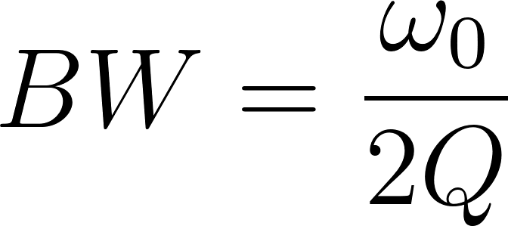](https://www.codecogs.com/eqnedit.php?latex=BW%20%3D%20%5Cfrac%7B%5Comega_0%7D%7B2Q%7D#0)

The peak current equation becomes:

[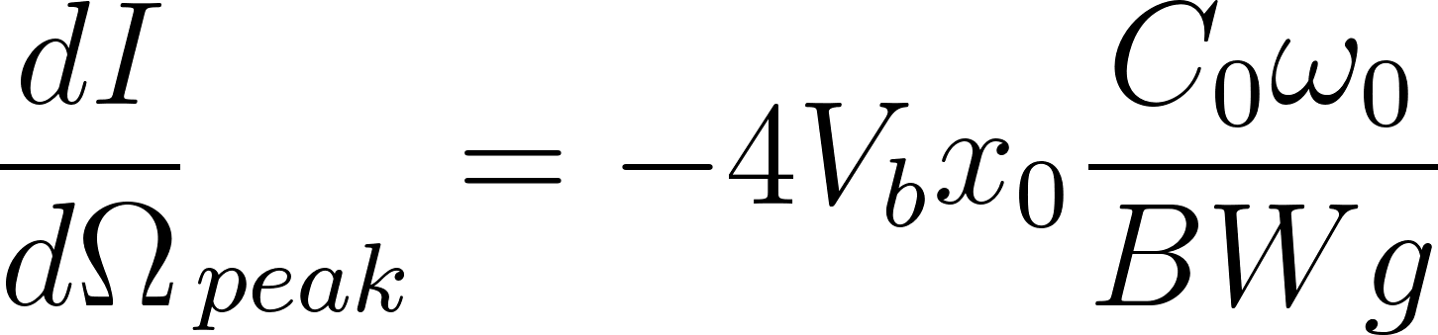](https://www.codecogs.com/eqnedit.php?latex=%7B%5Cfrac%7BdI%7D%7Bd%5COmega%7D%7D_%7Bpeak%7D%20%3D%20-4V_bx_0%20%5Cfrac%7BC_0%5Comega_0%7D%7BBWg%7D#0)

Using the formula of capacitance:

[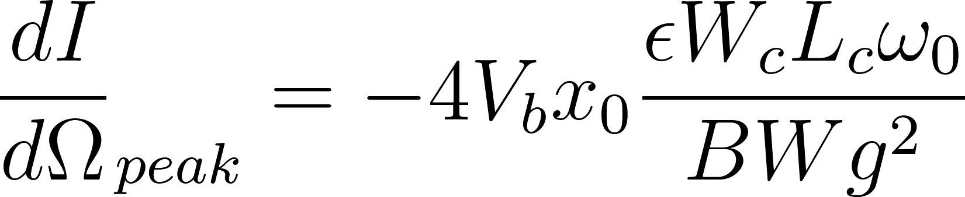](https://www.codecogs.com/eqnedit.php?latex=%7B%5Cfrac%7BdI%7D%7Bd%5COmega%7D%7D_%7Bpeak%7D%20%3D%20-4V_bx_0%20%5Cfrac%7B%5Cepsilon%20W_c%20L_c%20%5Comega_0%7D%7BBWg%5E2%7D#0)

As, gap is limited to min 2 um and width is determined by the aspect ratio of 20.

Now, coming to the natural frequency, which is given as:

[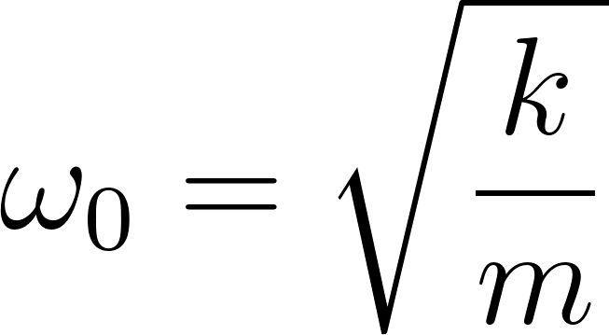](https://www.codecogs.com/eqnedit.php?latex=%5Comega_0%20%3D%20%5Csqrt%5Cfrac%7Bk%7D%7Bm%7D#0)

We assumed a spring constant of 50 as we found it common among the MEMS devices, and thus calculated the sense mass. Then, from sense mass, we calculated the dimensions of the sense mass. This leads to the limit on the length of the capacitor plate as it is integrated within the sense mass structure.

It is obvious that the drive mass is going to be larger than the sense mass; and to match drive frequency with the sense frequency we increased the spring stiffness on the drive side. But to achieve the required peak displacement in the x-direction, we increased the drive force by adding more comb fingers.

Thus the design process of the gyroscope has been extremely iterative and needed reasonable constraints arising from the manufacturing limitations and physics of the problem as explained.

Peak displacement in y-direction is given by:

[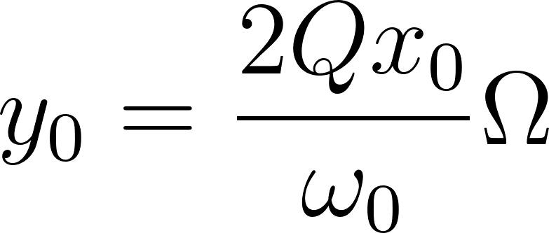](https://www.codecogs.com/eqnedit.php?latex=y_0%20%3D%20%5Cfrac%7B2Qx_0%7D%7B%5Comega_0%7D%5COmega#0)

Since the bias voltage determines the pull in gap, the peak displacement is thus (⅔)g

We use this equation and the constraints on the peak current, bias voltage, natural frequency, bandwidth to determine peak drive disp

Drive side:

[](https://www.codecogs.com/eqnedit.php?latex=m%5Cddot%7Bx%7D%20%2B%20c%5Cdot%7Bx%7D%20%2B%20kx%20%3D%20F_%7B%5Ctext%7Bdrive%7D%7D#0)

1. Minimum current
2. Bandwidth
3. Thickness
4. Natural Frequency (10-30 kHz)
5. Bias Voltage/ Drive Voltage (Range)
6. Gap: 1.75 um
7. Aspect ratio = 20
8. Pull In

**Design Parameters**

| **Parameter** | **Value** |
| --- | --- |
| Overall Dimensions |  |
| Thickness |  |
| Sense Beam Length |  |
| Number of Sense and Drive Beams in Series |  |
| Sense & Drive Beam Width |  |
| Sense Mass Dimensions |  |
| Sense and Drive Capacitor Gap |  |
| # Sense Stators |  |
| Sense Stator Thickness |  |
| Sense Rotor Thickness |  |
| Drive Mass |  |
| Drive Spring Length |  |
| Drive Mass Dimensions |  |
| Bias Voltage |  |
| AC Drive Voltage |  |

**IV. FABRICATION PROCESS**

For our purposes, we have elected a SiOG (Silicon on glass) process to fabricate our gyroscope. While the traditional SOI (Silicon on insulator) process is more established and well-known, thermal expansion mismatch between the silicon structure and packaging material can induce a frequency shift in driving and sensing frequency, therefore degrading the overall performance target we are aiming to achieve. On the other hand, SiOG has been proven to reduce wafer bowing and subsequently the mismatch between driving and sensing frequency. As a result, we have chosen SiOG to fabricate our gyroscope, and a detailed process flow is described below.

* Starting with a 350 μm thick Pyrex glass wafer, as shown in 2(a), bottom cavities are fabricated by using a HF wet etch process.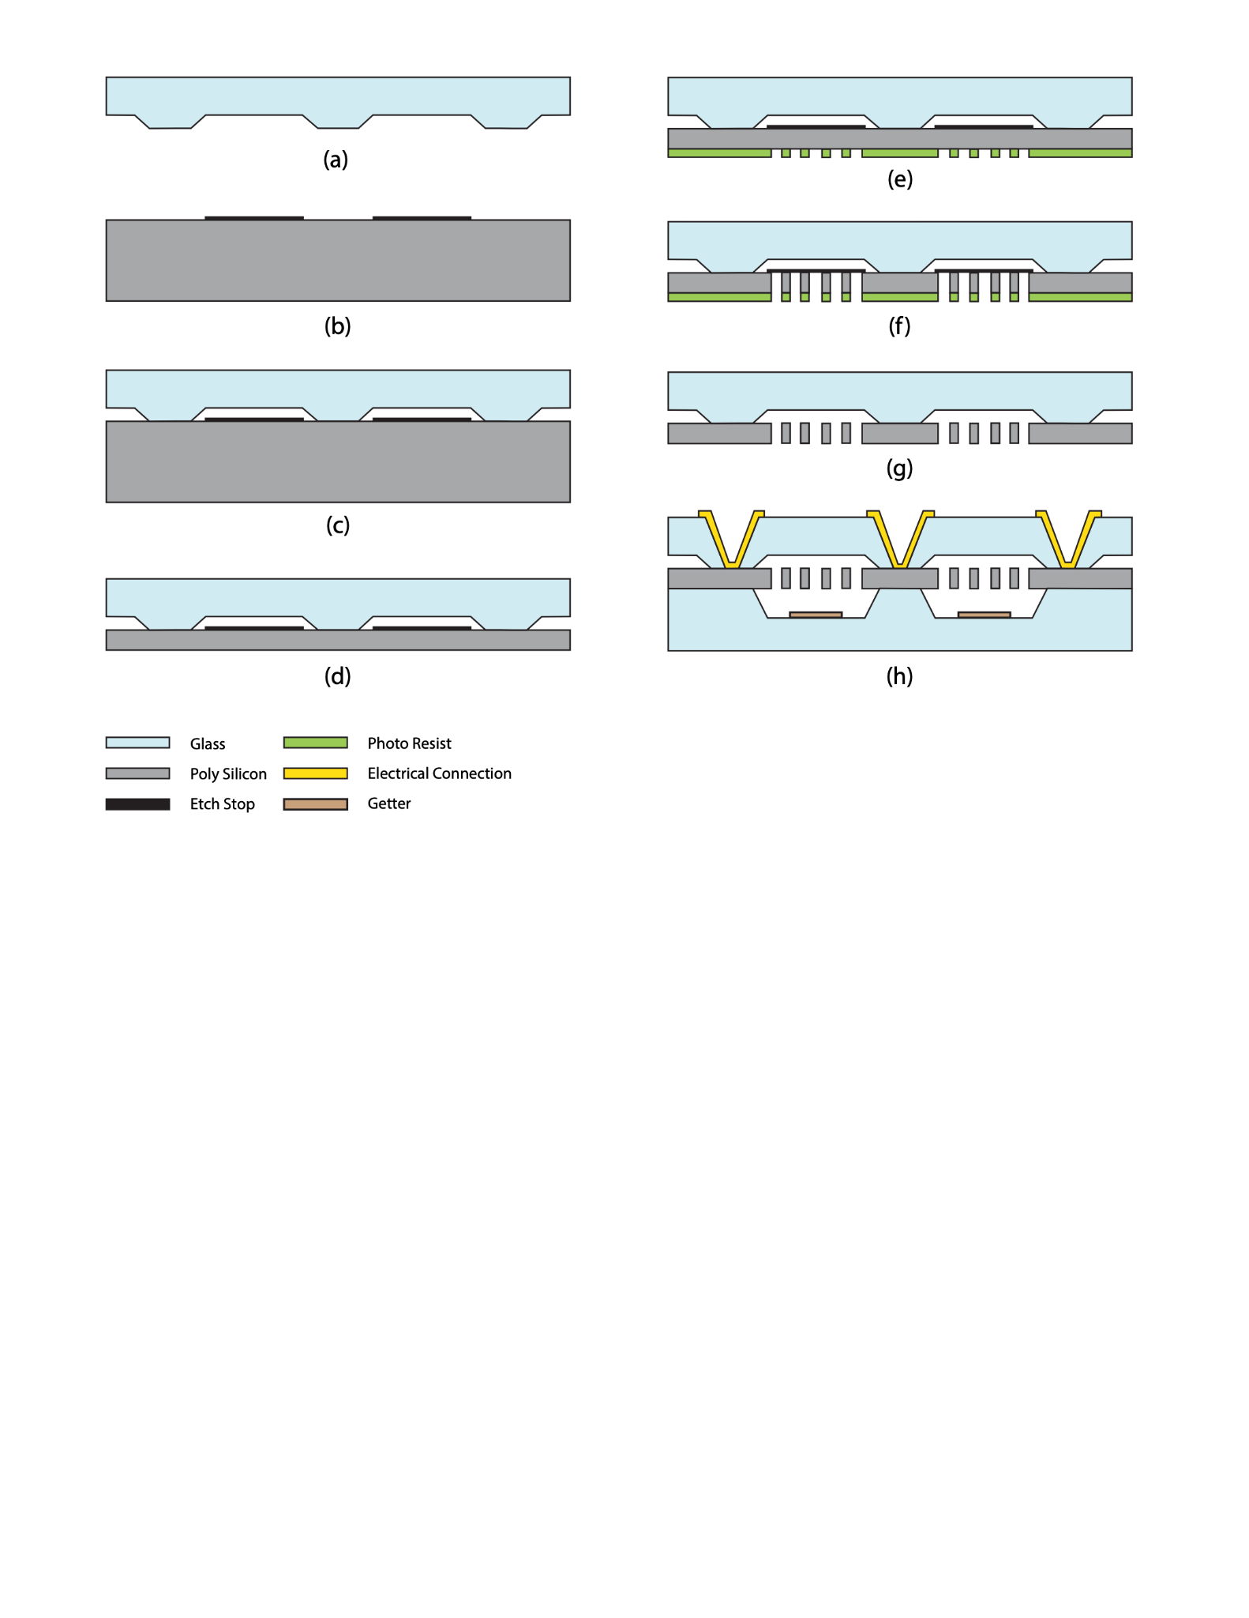
* In 2(b), we deposit 2 μm thick aluminum layers on top of the silicon wafer to serve as an etch stop in the upcoming process.
* After which the top glass wafer is combined with the silicon wafer by anodic bonding, as shown in 2(c).
* Subsequently, the silicon wafer is polished down to our desired thickness of 35 μm by CMP (Chemical Mechanical Polishing), seen in figure 2(d).
* Starting with a 350 μm thick Pyrex glass wafer, as shown in 2(a), bottom cavities are fabricated by using a HF wet etch process.
* In 2(b), we deposit 2 μm thick aluminum layers on top of the silicon wafer to serve as an etch stop in the upcoming process.
* After which the top glass wafer is combined with the silicon wafer by anodic bonding, as shown in 2(c).
* Subsequently, the silicon wafer is polished down to our desired thickness of 35 μm by CMP (Chemical Mechanical Polishing), seen in figure 2(d).
* In order to fabricate our design feature on the silicon wafer, we use dark field photoresist along with the ICP RIE (Inductively coupled plasma reactive ion etching) process, as shown in figure 2(e) and 2(f).
* After the etching process, the aluminum etch stop and photoresist are removed with sulfuric acid and an ashing process respectively.
* In figure 2(h), we prepare another 350 μm thick Pyrex glass wafer and fabricate cavities with a depth of 160 μm using a similar process.
* Before the bottom glass wafer is combined with the silicon structure, Ti is evaporated to the surface of the glass wafer as a coating in order to reduce and absorb various types of gasses trapped or produced inside the vacuum cavity during the fabrication process, thus ensuring a sufficiently high Q-factor for our purpose.
* Finally, via holes are fabricated using a sandblasting process, after which gold is evaporated onto the via hole surfaces to serve as electrical connections to the silicon structure.

**CONCLUSIONS AND FUTURE WORK**

A detailed design process along with the fabrication process for vibratory mass gyroscope has been presented. The gyroscope design is quite involved given the number of free variables and constraints at the same time. Also, without an application in view, it is difficult to come up with a device that can satisfy the application requirements. We can specify that the given gyroscope can measure velocities ranging from 0.166 rpm to 913 rpm. There will be a mismatch between the drive and sense frequency because of the manufacturing constraints and needs to be mitigated using electrostatic tuning, which has not been discussed here. This paper focused on the details of the dimensional design process and can serve as a good preliminary design guideline. Also, the noise plays an important role in the design process, which too has not been treated given the time and knowledge constraints.

**REFERENCES**

[1] F. Pistorio, “Design and FEM Simulation of dual mass resonant MEMS Gyroscope,” Masters Thesis, Politecnico Di Torino, 2020.

[2] Lee, Moon Chul, et al. “A High Yield Rate MEMS Gyroscope with a Packaged SiOG Process.” Journal of Micromechanics and Microengineering, no. 11, IOP Publishing, Sept. 2005, pp. 2003–10. Crossref, doi:10.1088/0960-1317/15/11/003.

[] Aaron Burg, Azeem Meruani, Bob Sandheinrich, and Michael Wickmann, “MEMS Gyroscopes and Their Applications,” Introduction to Microelectromechanical Systems, pp. 3-20.

[] Lee, Moon Chul, et al. “A High Yield Rate MEMS Gyroscope with a Packaged SiOG Process.” Journal of Micromechanics and Microengineering, no. 11, IOP Publishing, Sept. 2005, pp. 2003–10. Crossref, doi:10.1088/0960-1317/15/11/003.

[] Marc S. Weinberg, "How to Invent (or not Invent) the First Silicon MEMS Gyroscope," Draper Laboratory, Cambridge, MA, USA.

[]